R. Reports Menu: 6. Outstanding Checks

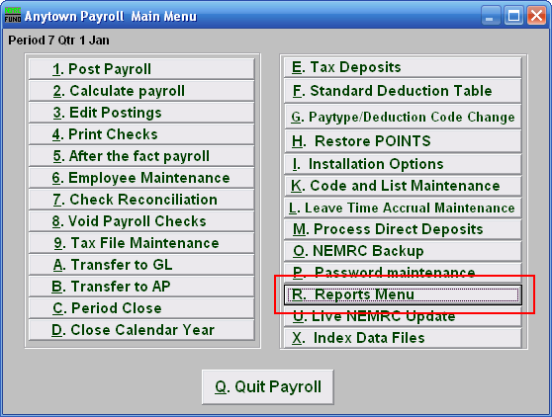
Click on “R. Reports Menu” from the Main Menu and the following window will appear:
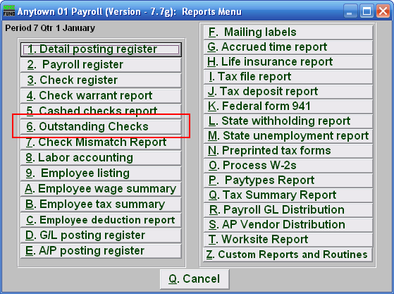

Click on “6. Outstanding Checks” from the Reports Menu and the following window will appear:
Outstanding Checks

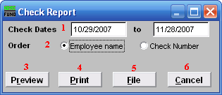
- Check Dates: Enter the beginning and ending check date range to collect records to report. Leave the beginning date empty to see all possible checks in the system.

- Order: Employee name OR Check Number: Click to choose whether this report prints in order of Employee name or in order of Check number.

- Preview: Click this button to preview this report. Refer to GENERAL PREVIEW for more information.

- Print: Click this button to print this report. Refer to GENERAL PRINTING for more information.

- File: Click this button to save this report on this computer. Refer to GENERAL FILE for more information.

- Cancel: Click “Cancel” to cancel and return to the previous screen.

